Q-11-1

1) Babies born with low birth weights (less than 2500 grams) are at an increased risk for many infant diseases. Researchers in North Carolina collected data to see what variables may influence the birth weight (in grams) of a child, including whether the mother drank alcohol during pregnancy, whether the mother smoked during pregnancy, the mother's age (years), the gestation of the pregnancy (number of weeks from conception until birth), the mother's race, the length of the birth (hours), and several others. The plot below summarizes some of the variables measured.
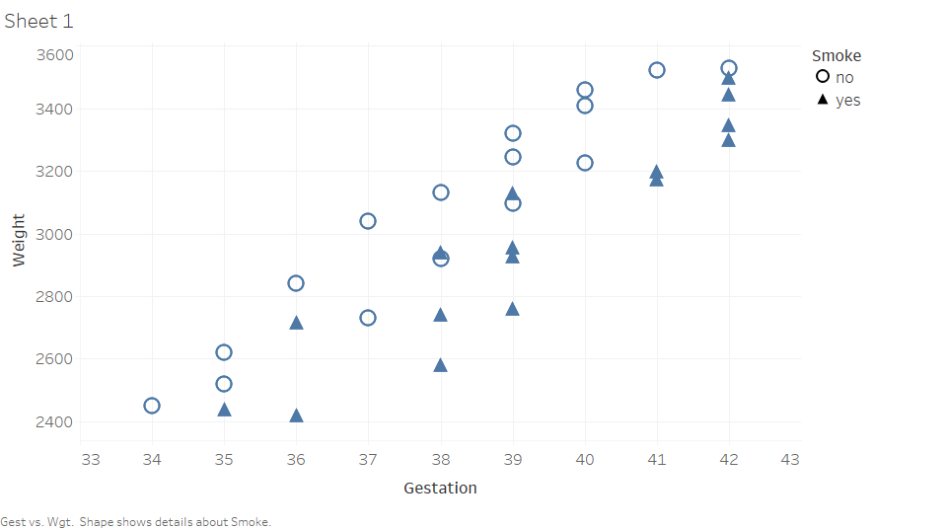
Based on the plot, does there appear to be an association between gestation period and birth weight?
a. Yes, because as one variable increases, the other tends to increase as well.
b. No, because as one variable increases, the other tends to increase as well.
c. Yes, because most of the circles on the plot appear to be higher than the triangles.
d. No, because one variable does not appear to change the other variable.

2) Which of the following correlation coefficient values describes the weakest linear association between two variables.
a. -0.99
b. -0.23
c. 0.12
d. 0.38

3) The following scatterplot displays the finish time (in minutes) and age (in years) for the male racers at the 2018 Strawberry Stampede (a 10k race through Arroyo Grande).
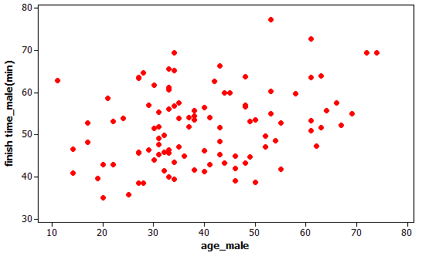
Approximate the value of the correlation coefficient for these data.
a. 0
b. 0.25
c. 0.50
d. 0.80

4) The graph below shows a scatter plot of medical expenses in the past year by age for a sample of Americans.
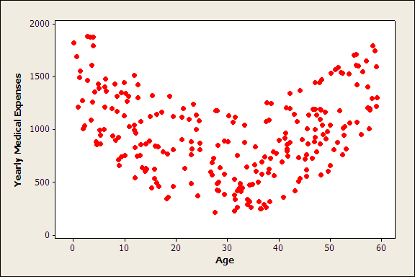
Which one of the following is a true statement about the data shown in the graph?
a. The correlation must be close to one because there is a strong relationship between age and medical expenses.
b. Using correlation on the data shown in the graph above is not appropriate because the relationship shown in the graph is not linear.
c. Both A and B are true statements.
d. Neither A nor B is a true statement.

5) The following scatterplot displays the finish time (in minutes) and age (in years) for the male racers at the 2018 Strawberry Stampede (a 10k race through Arroyo Grande).
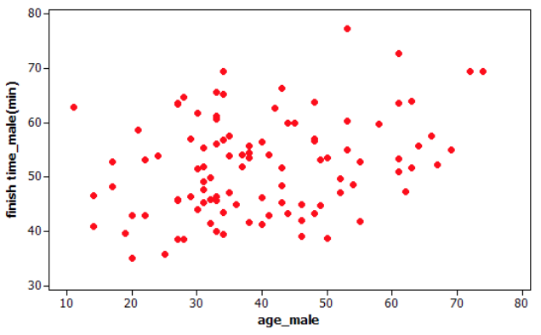
If a 70-year-old male with a finishing time of 35 minutes was added to the data set, would the correlation coefficient increase, decrease, or remain the same?
a. Increase
b. Decrease
c. Remain the same
d. Unable to determine with the information provided

6) Babies born with low birth weights (less than 2500 grams) are at an increased risk for many infant diseases. Researchers in North Carolina collected data to see what variables may influence the birth weight (in grams) of a child, including whether the mother drank alcohol during pregnancy, whether the mother smoked during pregnancy, the mother's age (years), the gestation of the pregnancy (number of weeks from conception until birth), the mother's race, the length of the birth (hours), and several others. The plot below summarizes some of the variables measured.
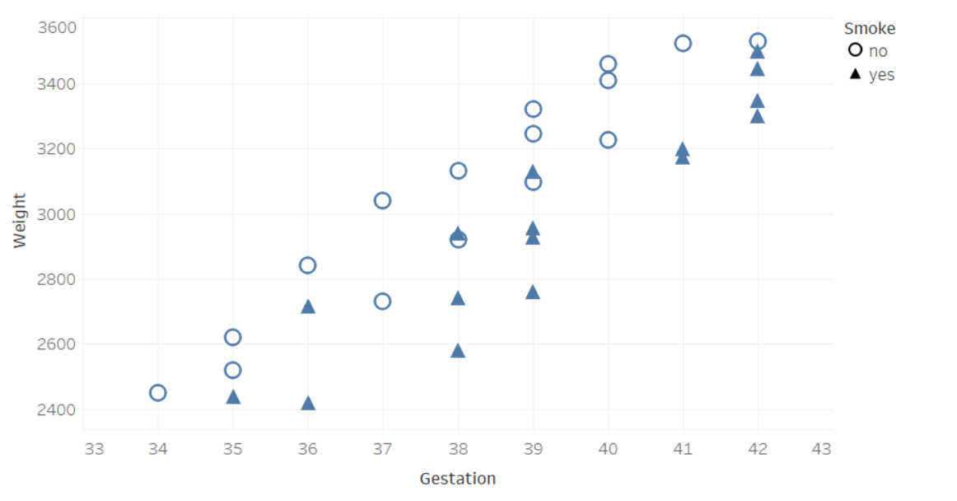
How would the correlation coefficient between birth weight and gestation period computed from all women in the sample compare to the correlation coefficient between birth weight and gestation period computed from only non-smoking women?
a. The correlation coefficient for the entire sample would be closer to 1 than the correlation coefficient for the non-smoking group.
b. The correlation coefficient for the entire sample would be closer to 0 than the correlation coefficient for the non-smoking group.
c. The correlation coefficient for the entire sample would be the same as the correlation coefficient for the non-smoking group.
d. We cannot determine how the two correlation coefficients compare based on this plot.

